**Term 2 – 2024**

**BIOLOGY**

**FORM 4**

**Time: 13/4Hours**

**Name**: ………………………………………............**Adm No**: ……….…......

**Stream**: ………………**Candidate’s** **Signature**: …….……..**Date**: ….…

**School …………………………………………………………….**

**INSTRUCTIONS TO CANDIDATES:**

* *Write your* ***name*** *and* ***admission number*** *in the spaces provided.*
* *Sign and write* ***date*** *of examination in the spaces provided above*
* *Answer* ***all*** *the questions in this paper.*
* *You are required to spend the first 15 minutes of the 1¾ hours allowed for this paper reading the whole paper carefully.*

***For Examiner’s Use Only:***

|  |  |  |
| --- | --- | --- |
| **QUESTIONS** | **MAXIMUM SCORE** | **CANDIDATE’S SCORE** |
| 1 | 14 |  |
| 2 | 12 |  |
| 3 | 14 |  |
| **TOTAL** | **40** |  |

**1.** You are provided with 10cm3solution Q, a mixture of certain food substance, Iodine solution and Benedict’s solution. Using the provided labels identify two test tubes as A and B. Divide solution Q into two equal portions and place into the two test tubes labeled A and B.

a) Using the contents of test tube A, and the provided reagents, carry out food test hence fill the table below. (6 marks)

|  |  |  |  |
| --- | --- | --- | --- |
| Food substance | Procedure | Observation | Conclusion |
|  |  |  |  |
|  |  |  |  |

b) Add 3cm3 of solution N into test tube B then place in a water bath maintained at 300c for 10 minutes. Remove from the water bath and repeat the test in (a) above. Then fill the table below. (4marks)

|  |  |  |  |
| --- | --- | --- | --- |
| Food substance | procedure | Observation | Conclusion |
|  |  |  |  |
|  |  |  |  |

(c) Suggest the identity of N  (1mark)

………………………………………………………………………………………………………………………………………………………………………………………………………………

d) Account for the results in table for (b) above.  (3marks)

………………………………………………………………………………………………………………………………………………………………………………………………………………………………………………………………………………………………………………………………………………………………………………………………………………………………………………………………………………………………………………………………………………………………………………………………………………………………………………………………………………………………………………………………………………………………………………………………………………………………………………………………

**2.** The photographs below show evidence of different structures that indicate evidence of evolution.

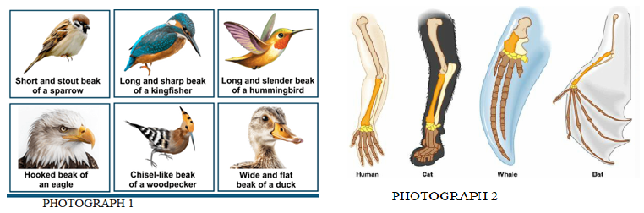

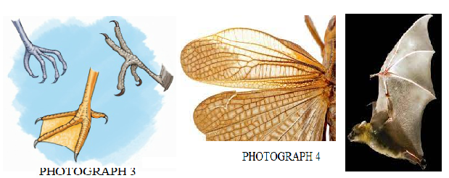

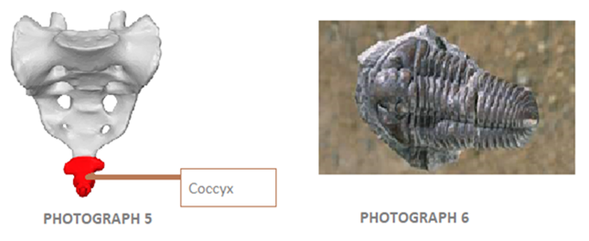

(a) Name the evidence represented by photographs 1, 2, 3 and 4.  (1 mark)

……………………………………………………………………………………………………..

(b) Name the type of structures represented by photograph 4. (1 mark)

………………………………………………………………………………………………………

(c) Name the common evolutionary phenomenon exhibited by structures in photographs 1, 2 and 3.  (1 mark)

…………………………………………………………………………………................................

(d) (i) All the birds with the different beaks and feet shown above once had a common ancestor. Name the type of evolution shown by the emergence of the different beaks and feet many years later. (1 mark)

………………………………………………………………………………………………………

(ii) In photograph 3, a webbed feet of a duck is represented. Suggest how Lamarck would have explained the emergence of this type of feet. (3 marks)

………………………………………………………………………………………………………………………………………………………………………………………………………………………………………………………………………………………………………………………………………………………………………………………………………………………………

(iii) Photograph 6 shows a fossil of a trilobite. Trilobites are extinct. Suggest how Darwin would have explained the cause of their extinction. (2 marks)

………………………………………………………………………………………………………………………………………………………………………………………………………………………………………………………………………………………………………………………

e) Name the organism that exhibits the evidence in photograph 5. (1 mark)

………………………………………………………………………………………………………

f) (i) Give two observable features that would help in classifying organisms in photograph 1 into their correct class. (2 marks)

…………………………………………………………………………………………………….

…………………………………………………………………………………………………….

**3.** You are provided with specimen **M** and **N** obtained from two different plants. Take specimen M and carefully cut it longitudinally into two halves. Place a drop of iodine solution on each cut surface of the specimen. Leave it for two minutes, then wash the cut surface with water. Repeat the same procedure with specimen **N**. Using a hand lens, observe the colour changes.

a) i) State observations in each case; **M** and **N**  (2 marks)

Specimen **M** ……………………………………………………………………………………….

Specimen **N**……………………………………………....................................................................

ii) Explain the distribution of colour on the surfaces of each specimen **M** and **N**. (2 marks)

……………………………………………………………………………………………………………………………………………………………………………………………………………………………………………………………………………………………………………………....

b) The photograph below illustrates the germination of specimen **N** after it was planted.

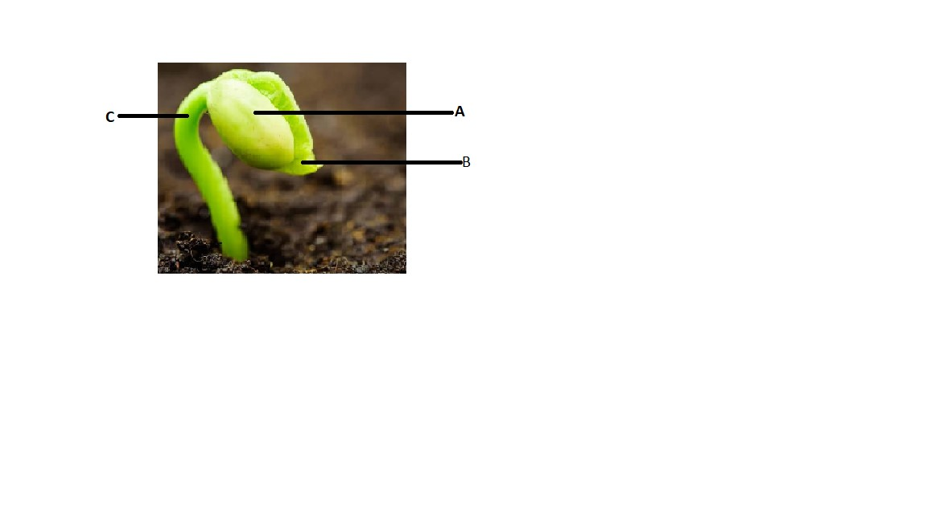

i) Giving a reason, identify the type of germination shown. (2 marks)

Type ……………………………………………………………………………………………….

Reason ……………………………………………………………………………………………

……………………………………………………………………………………………….

ii) Name the parts **B** and **C**   (2 marks)

**B** ……………………………………………………………………………………………………

**C** ………………………………………………………………………………………………….

iii) Give three roles of part **A** during germination  (3 marks)

……………………………………………………………………………………………………………………………………………………………………………………………………………………………………………………………………………………………………………………...

c) Explain how the part labeled **C** eventually straightens up after a few days of growth (3 marks)

………………………………………………………………………………………………………………………………………………………………………………………………………………………………………………………………………………………………………………………………………………………………………………………………………………………………